Growing knowledge, skills and wisdom  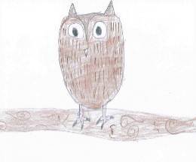 | Growing through community and living well together  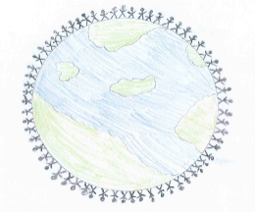 | Growing dignity and respect   | Growing hope and aspiration  
Two of the most amazing Ice Explorers were Robert Falcon Scott and Roald Amundson.  You could research all the great achievements of Robert Falcon Scott OR Roald Amundsen.  Create a fact file full of information about their greatest achievements.  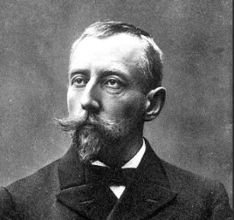  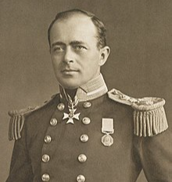 |   Ice Explorers travelled to the South Pole in Antarctica. The weather in Antarctica is extremely cold.  Go on a walk to observe and describe the weather and compare it to the weather in Antarctica.    You could create an information booklet including the things you would take and why if you were an explorer. | Can you create a poster to inform people about the dangers our polar animals face?  You could include:  Which animals are endangered?  How are they endangered?  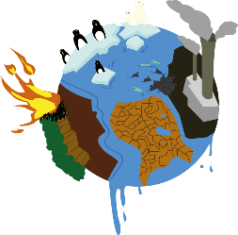  What can we do to help them?  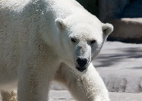 | What do you aspire to be when you grow up?  What job would you like to do and why?  You could record a video of yourself explaining what you would like to be and why. You could even dress up for the occasion.  

