Growing knowledge, skills and wisdom  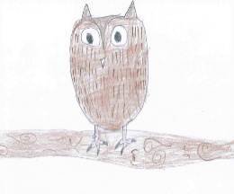 | Growing through community and living well together  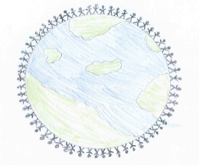 | Growing dignity and respect   | Growing hope and aspiration  
British Landmarks.  Can you research about a famous British landmark?  You could create a 3D model to represent the landmark you have chosen and write some fantastic facts. | Favourite British Meal  Can you make your favourite British meal? You can do this with an adult.  Take a photo of your meal and create some instructions to go with it. This way, others can share your favourite British meal. | What are British Values?  Can you design a poster about each of the British Values?  What do the British Values mean to you?  Make your poster personal to you. Use your own words. | Famous British People  There are many artists, musician and inventors who were born in Britain.  Create a fact file about one famous British person.  You should include:  Why they are famous.  Where they lived.  Some of their achievements.  Maybe you could create something in their style?

