Growing knowledge, skills and wisdom  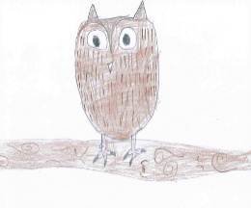 | Growing through community and living well together  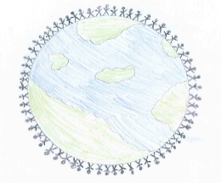 | Growing dignity and respect   | Growing hope and aspiration  
Can you create a simple, one-page newspaper article reporting on what happened during The Gunpowder Plot?  Please include the following:  - Newspaper name  - Headline  - Picture    - Short description of what happened | Can you design a bonfire safety poster detailing all the ways you can stay safe whilst enjoying the bonfire and firework displays.   | 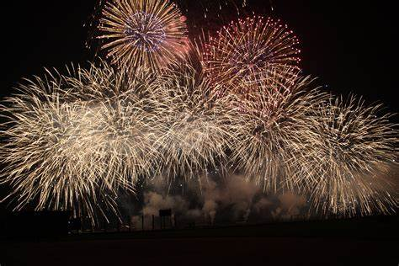  Can you research when and how fireworks are used to celebrate special occasions in other religions. | The fire service keeps us safe every day. They are amazing!  Can you research what fire officers do in their day-to-day role and what it takes to become a fire officer.  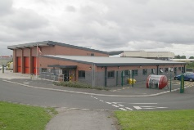  After completing your research, you could write a letter to the local station to say thank you for all their hard work.

