Growing knowledge, skills and wisdom  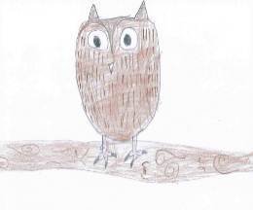 | Growing through community and living well together  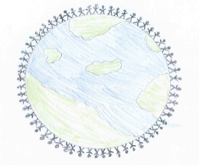 | Growing dignity and respect  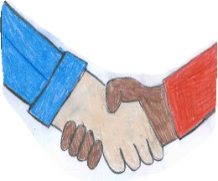 | Growing hope and aspiration  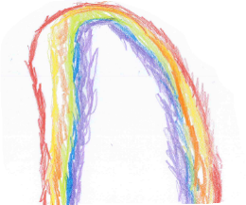
The world is made up of 7 continents and 5 oceans. Record a video of yourself naming all 7 continents and 5 oceans.  Then choose one continent and ocean to research more information about.  You might want to research:  Where it is located  The population | Can you investigate your local area using ‘Google Maps’ to help you?  You might want to draw a map of your house and the things around it.  Label the places in your local area when drawing your map to show people what is in the area. | The 5 oceans of the world are the home to many different creatures.  Can you research about the different creatures and animals that live in one of the oceans?  What can or should we do to protect them animals? | Pirates sail the oceans and take over land. They love to look for treasure.  Could you create a poster to warn people about possible pirates?  Please include:  What they look like.  What they wear.  How they travel.  What they do.  Would you like to be a pirate?

