Growing knowledge, skills and wisdom  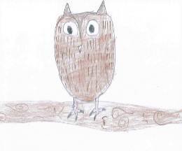 | Growing through community and living well together  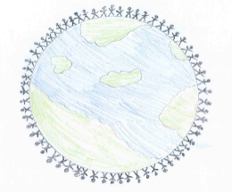 | Growing dignity and respect   | Growing hope and aspiration  
Can you research different species of dinosaur? Choose your favourite one and create a fact file about it. You could include:  - Name  - Labelled picture  - Interesting fact  - Diet  - Habitat | Can you take a trip to a local library or museum (Manchester Museum is fab!) to look at dinosaur skeletons and models? What did you find out? You could write a recount of your day trip starting from when you got up to when you got home. You could record this or write it as a diary entry. | Just like dinosaurs, we have many animals that are on the endangered species list. Can you create poster to show how we can help wild animals by being respectful of their habitats? What should we do to help? What shouldn’t we do? Why is it important to protect them? | What is a palaeontologist? Can you find out how you could become one? What qualifications and experience do you need? Complete this activity with some creative fun by creating your own fossils in playdoh or salt dough https://www.bbcgoodfood.com/howto/guide/how-make-salt-dough-recipe  Push pasta shells and other objects into the dough to create your own dinosaur fossil!  